1 | 808010900344 | 8128 捻钞轮组件-  A2 | Twiddling wheel subassembly | 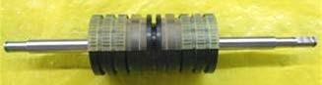 | 40
2 | 801090000215 | 1011A进钞轮组件加工 | Synchronous feeding wheel | 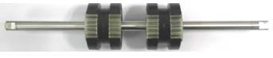 | 30
3 | 801090000192 | 8128  送钞轮F组件 | Delivering  Wheel F  Subassembly | 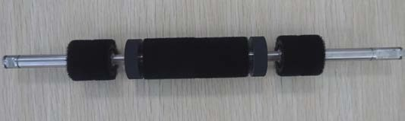 | 20
4 | 801090000149 | 8128  送钞轮H组件 | Delivering wheel H  Subassembly | 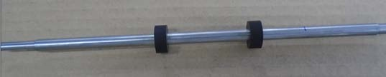 | 20
4 | 801090000012 | 8110  送钞轮C组件-A3 | Delivering wheel C subassembly | 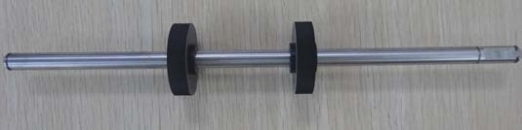 | 10
5 | 801090000032 | 8120（VB）送钞轮D组件-A2 | Delivering wheel D subassembly | 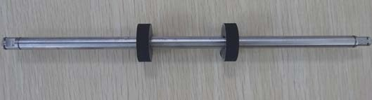 | 10
6 | 801090000030 | 8110  送钞轮E组件 | Delivering wheel E subassembly | 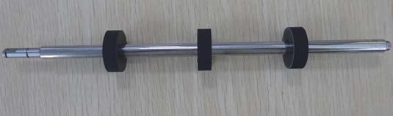 | 10
7 | 808010900210 | D组红外板组件 | Group D IR subassembly | 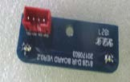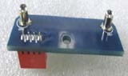 | 10
8 | 808010900,0069 | 退钞传感器组件 | Banknote rejecting board subassembly | 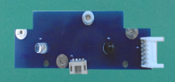 | 10
  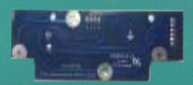
9 | 808010900,0211 | E组红外板组件 | Group E IR subassembly | 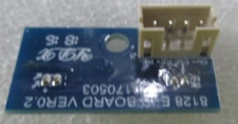  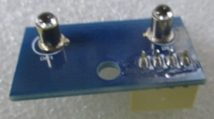 | 10
10 | 808010900,0550 | E组红外板组件 | Group E IR subassembly | 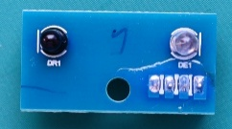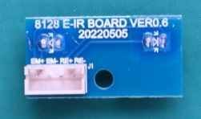 | 10
11 | 808010900,0197 | 8128 UV支架板组件 | UV sensor board subassembly | 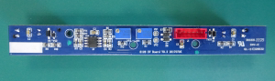  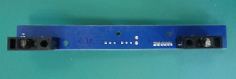 | 10
12 | 808010900,031 | A红外支架板组件 | Group A infrared subassembly | 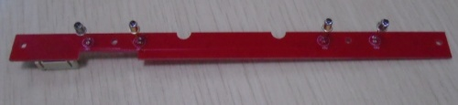 | 10
13 | 808010900,0077 | 8120VB B+D红外发射组件 | B&D IR emitting subassembly | 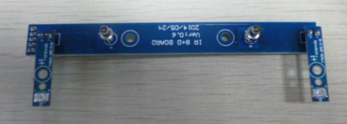 | 10
14 | 808010900,0267 | BX红外发射板组件 | BX IR emitting subassembly | 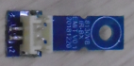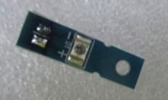 | 10
15 | 808010900,0066 | 8120VB C组红外组件 | Group C IR subassembly | 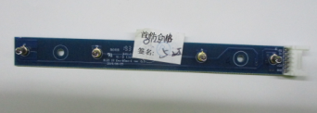 | 10
16 | 808010900,0311 | C组红外板组件 | Group C IR subassembly | 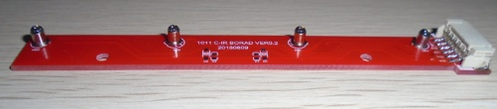 | 10
17 | 808010900,0018 | 进钞传感器组件 | Banknote feeding sensor subassembly | 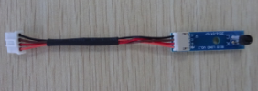  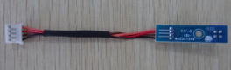 | 10
18 | 808010900,0067 | 8120VB进钞码盘 传感器组件 | Rotate speed sensor for feeding | 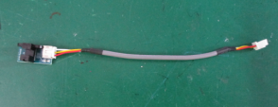 | 10
19 | 808010900,0068 | 8120VB送钞码盘传感器组件 | Rotate speed sensor for delivering | 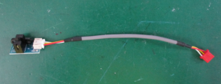 | 10
20
808010900,0212 | 8128 传动轮3M-36 | Transmission wheel 3M-36 | 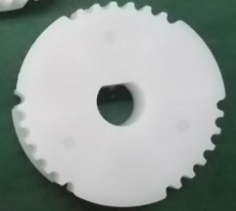  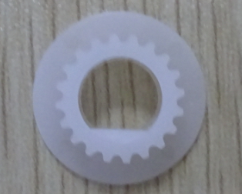  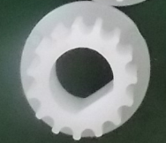  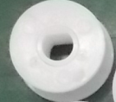  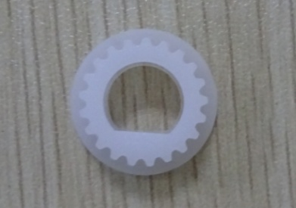  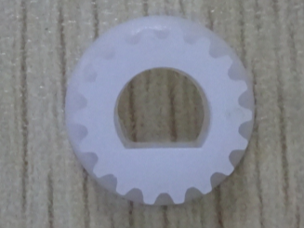  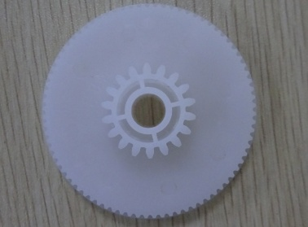  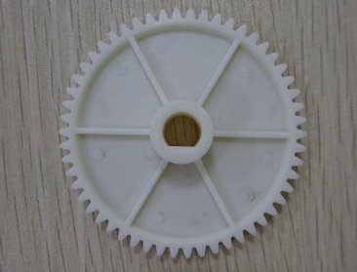  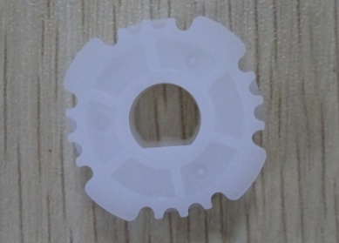  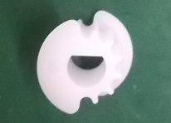  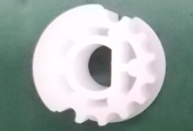  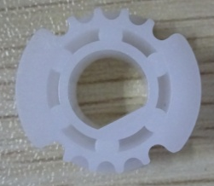  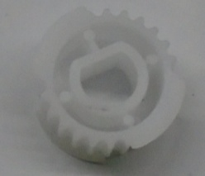  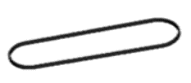 | 100
808010900,0032 | 8110传动轮B组件 | Transmission wheel B |  | 200
808010900,0033 | 8110传动轮C组件 | Transmission wheel C |  | 200
808010900,0034 | 8110传动轮D组件 | Transmission wheel D |  | 50
808010900,0036 | 8110传动轮E | Transmission wheel E | 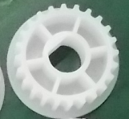 | 200
808010900,0035 | 8110 单向轴承传动轮 | Unilateral transmission wheel | 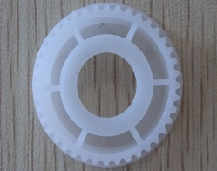 | 200
808010900,0037 | 8110传动轮S2M-28 | S2M-28 Transmission wheel | 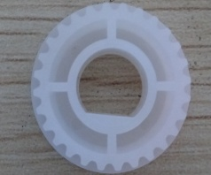 | 200
808010900,0038 | 8110传动轮S2M-21 | S2M-21 Transmission wheel |  | 200
808010900,0093 | 传动轮S2M-18-D6 | S2M-18-D6 Transmission wheel |  | 100
808010900,0039 | 8110 接钞换向变速轮-A2 | Receiving transform wheel-A2 |  | 20
808010900,0040 | 8110 接钞传动齿轮 | Receiving transmission gear |  | 20
808010900,0289 | 8300 同步轮 H3M-24 | Synchronous wheel H3M-24 |  | 200
808010900,0213 | 同步轮3M-12 | Transmission wheel 3M-12 |  | 1000
808010900,0214 | 同步轮3M-15 | Transmission wheel 3M-15 |  | 200
808010900,0410 | 同步轮3M-18 | Synchronous wheel 3M-18 |  | 200
808010900,0411 | 同步轮S2M-24 | Synchronous wheel S2M-24 |  | 100
808010900,0042 | 8110同步带-188 | Synchronous strap-188 |  | 80
808010900,0043 | 8110同步带-246 | Synchronous strap-246 | 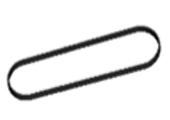 | 80
808010900,0096 | 8110同步带-212 | Synchronous strap-212 | 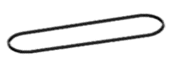 | 80
808010900,0047 | 8110同步带-240 | Synchronous strap-240 | 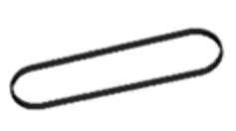 | 60
808010900,0215 | 同步带-213 | Synchronous strap-213 | 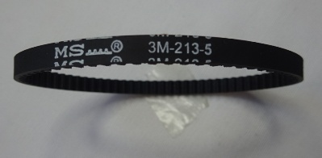 | 80
808010900,0191 | 同步带-206 | Synchronous strap-206 | 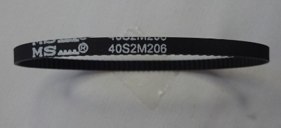 | 80
808010900,0046 | 同步带-108 | Synchronous strap-108 | 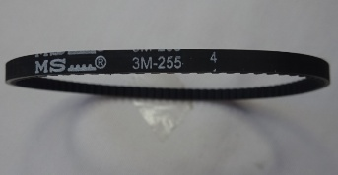  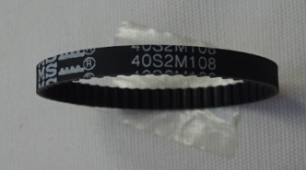 | 80
808010800,0029 | 同步带-255 | Synchronous strap-255 |  | 80
808010900,0080 | 同步带-114 | Synchronous strap-114 | 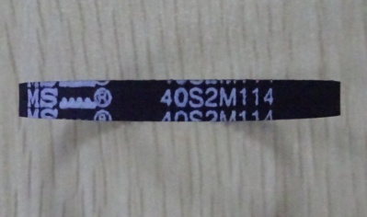 | 80
808010900,0044 | 同步带-180 | 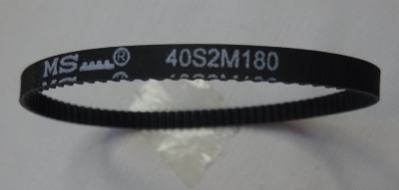  Synchronous strap-180 |  | 80
808010900,0288 | 同步带-285 | Synchronous strap-285 | 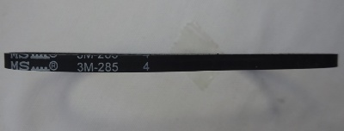 | 80
808010900.0559 |  |  | 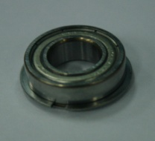 | 200
808010900.02.17 |  |  |  | 200
808011700.0198 |  |  |  | 200
808010900.0164 |  |  | 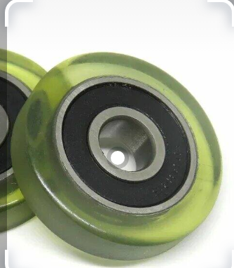 | 100
808010900.0301 |  |  | 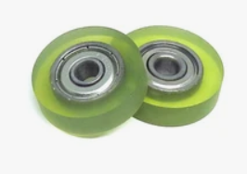 | 100

