Appendix A Parts List

Note: After replacing or dismantling BV or replacing the core board for BV, re-calibration is needed.

NO. | Part number | Description | Picture | Remark
1 | 808011700191 | BV subassembly | 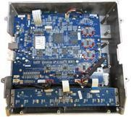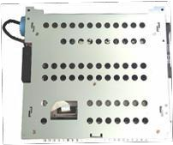
1-1 | 801170101055 | Opposite wheel A subassembly | 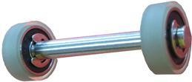 | 30
1-2 | 808011800125 | Magnetic sensor | 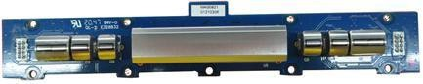  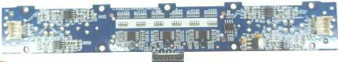 | 40
1-3 | 808011400128 | CIS subassembly | 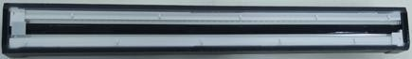 | 5

1-6 | 801190101071 | Thickness measuring subassembly | 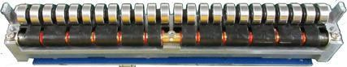  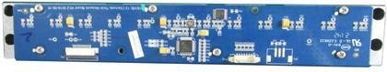 | 30

1-7 | 808011700091 | IR board | 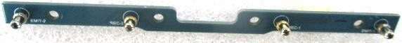 | 10
1-8 | 808011700081 | Banknote pressing stick with hairs |  | 30
1-9 | 808010900531 | Thickness measuring shaft |  | 40
1-10 | 808011700092 | Delivering wheel A subassembly | 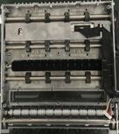 | 20
1-11 | 808011700093 | Delivering wheel B subassembly | 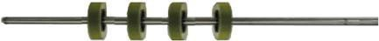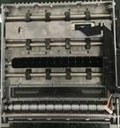 | 30
1-12 | 808011700094 | Delivering wheel C subassembly | 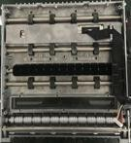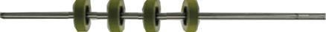 | 30

1-13 | 808011700031 | Synchronous belt-216 | 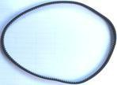 | 50
1-14 | 808011700032 | Synchronous belt-172 | 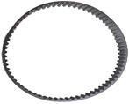 | 50
1-15 | 808011700033 | Synchronous belt-124 | 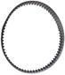 | 50
1-16 | 808011700077 | Synchronous belt-160 | 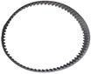 | 50
1-17 | 808011700024 | Synchronous belt-177 | 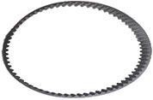 | 50
1-18 | 808011700026 | Synchronous strap wheel  S2M-28 | 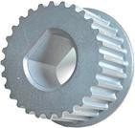 | 10

1-19 | 808011700022 | Synchronous strap wheel  S3M18-8-8P | 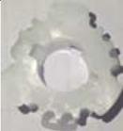 | 100
2
2-1 | 801190101119 | Shaft 1 subassembly of CT | 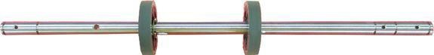 | 40
2-2 | 801190101069 | Shaft 4 subassembly of CT | 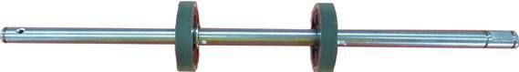 | 40
2-3 | 801190101069 | Shaft 3 subassembly of CT | 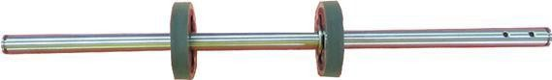 | 50
2-4 | 808011700002 | Synchronous belt-165 | 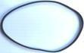 | 50

2-5 | 808011700025 | Synchronous strap wheel S3M22-8-8P | 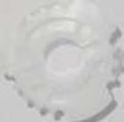 | 100
2-6 | 808011700026 | Synchronous strap wheel  S2M-28 |  | 10
3 | 808011700168 | FT subassembly | 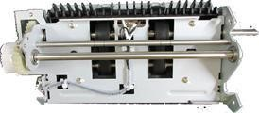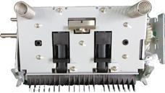 | 0
3-1 | 808011700099 | FT 3 subassembly | 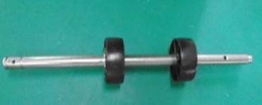 | 40
3-2 | 808011700100 | FT 8 subassembly | 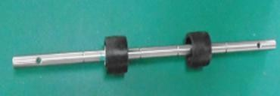 | 40
3-3 | 808011700101 | FT 7 subassembly | 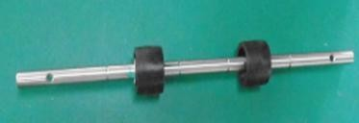 | 40

3-4 | 808011700020 | Flat belt-139 | 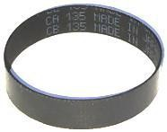 | 100
3-5 | 808011700014 | Flat belt-194 | 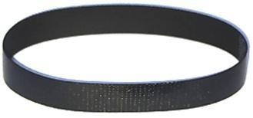 | 100
3-6 | 808010900532 | Left helical gear | 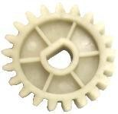 | 100
3-7 | 808010900533 | Right helical gear | 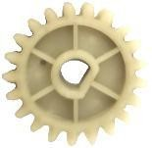 | 100
3-8 | 808011700023 | Synchronous strap wheel S3M32-8-8P | 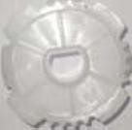 | 100
4 | 808011700173 | RS subassembly | 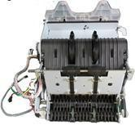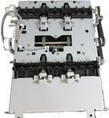 | 0

4-1 | 801190101047 | Shaft 2 subassembly of 8K-RS | 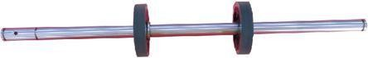 | 30
4-2 | 801220101017 | Shaft 2 subassembly of 8K CT | 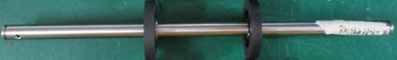 | 30
4-3 | 808011700102 | Shaft 2 subassembly of RS | 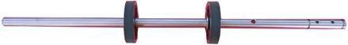 | 30
4-4 | 808011700103 | Shaft 3 subassembly of RS | 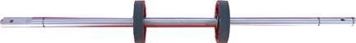 | 30
4-5 | 808011700105 | Shaft 5 subassembly of RS | 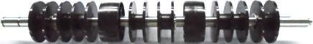 | 40
4-6 | 808011700106 | Shaft 6 subassembly of RS |  | 40

4-7 | 808011700002 | Synchronous belt-165 | 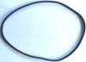 | 50
4-8 | 808011700035 | Synchronous belt-264 | 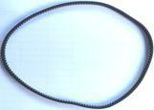 | 50
4-9 | 808011700107 | Synchronous belt-147 | 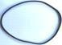 | 50
4-10 | 808011700023 | Synchronous strap wheel S3M32-8-8P |  | 100
4-11 | 808011700135 | Cylindrical gear 32-5-8P | 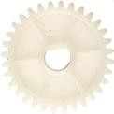 | 50
4-12 | 808011700025 | Synchronous strap wheel S3M22-8-8P | 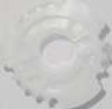 | 100

4-13 | 808011700137 | Synchronous pulley  S3M14-5-6P | 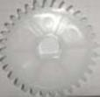 | 100
4-14 | 808010900535 | Gear subassembly  18-5-1 | 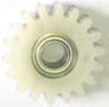 | 50
4-15 | 808011700076 | Flat belt-130 | 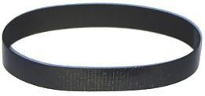 | 100
4-16 | 808011700021 | Flat belt-245 | 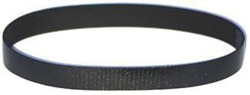 | 100
5-1 | 808011700015 | Flat belt-522 | 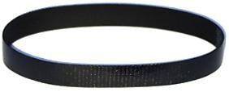 | 100

5-2 | 808011700075 | Flat belt-331 | 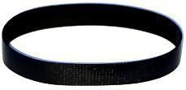 | 100
5-3 | 808011700108 | RT 2 subassembly | 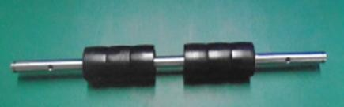 | 40
5-4 | 808011700109 | RT 4 subassembly | 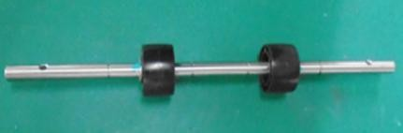 | 40
5-5 | 808011700110 | RT 6 subassembly | 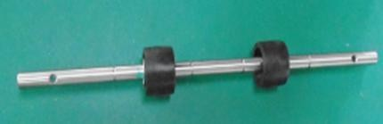 | 40
5-6 | 801190101121 | RT 7 subassembly | 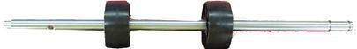 | 40
5-7 | 808011700112 | RT 10 subassembly | 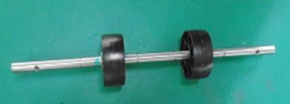 | 40

5-8 | 808011700113 | RT 12 subassembly | 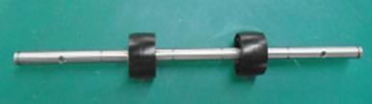 | 40
5-9 | 808011700114 | RT 13 subassembly | 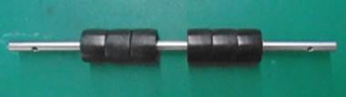 | 40
5-10 | 808011700026 | Synchronous strap wheel  S2M-28 | 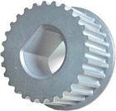 | 20
5-11 | 808011700087 | SK 2 subassembly | 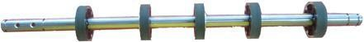 | 50
5-12 | 808011700023 | Synchronous strap wheel S3M32-8-8P |  | 100
5-13 | 808011700025 | Synchronous strap wheel S3M22-8-8P | 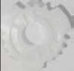 | 100
5-14 | 808011700137 | Synchronous strap wheel S3M14-5-6P |  | 100
5-15 | 808011700138 | cylindrical  gear 16-5-  6P | 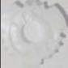 | 100
5-16 | 801190101114 | Note Pick up wheel subassembly | 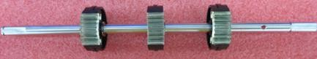 | 30
6 | 808010900534 | Twiddling wheel subassembly | 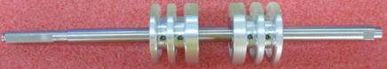 | 30
7 | 801190101115 | FM  Transmission wheel subassembly | 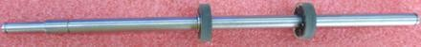 | 40
8 | 808011700140 | FM Reverse wheel subassembly | 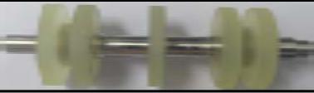 | 20
9 | 808011700135 | Cylindrical gear 32-5-8P |  | 100
10 | 808011700134 | Cylindrical gear 22-5-8P | 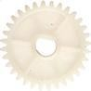 | 100
11 | 808011700138 | cylindrical  gear 16-5-  6P | 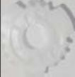 | 100
12 | 808011700029 | IR receiving diode | 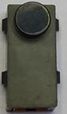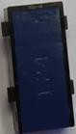 | 10
13 | 808011700030 | IR emitting diode | 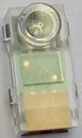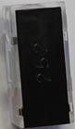 | 10
14 | 808011700073 | 4706 U typed sensor for MCB main motor | 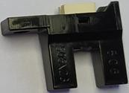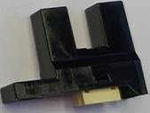 | 10
15 | LF-1680HHR |  | 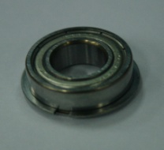 | 200
16 | L-1680HH |  | 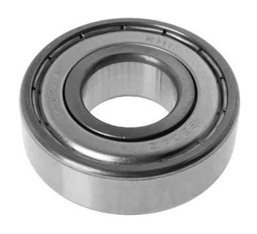 | 100
17 | 808011700072 | 4506 U typed sensor for FM |  | 10

